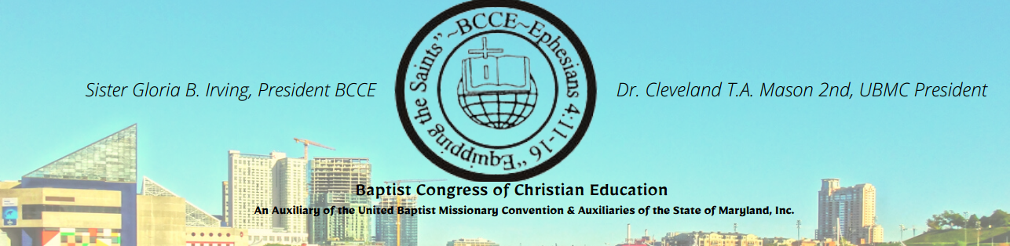
BCCE VIRTUAL WINTER CHRISTIAN LEADERSHIP SCHOOL

Saturday, January 15, 2022 – 7:30 AM – 4:00 PM Registration Fee $25.00
Certified Courses:
#1007 – Introduction to the Old Testament – Included in this course will be a general overview of the divisions, times, places, with emphasis on the nation of Israel, events, people, and archaeology of the Old Testament.
#1075 – The Synoptic Gospels – Focus on the Synoptic Gospels – Matthew, Mark, Luke. Students will study the life and ministry of Jesus Christ as portrayed by these three writers. Through this comparative study, students will gain a more comprehensive understanding of Jesus’ ministry.
#2015 – Foundation of Christian Ethics – Focus on understanding the philosophical and Christological approaches to Christian ethics. Engage in biblical principles for decision making and conduct for living.
#2097 – Rethinking Christian Education – Examine the current trends, methodologies, and practices in Christian education to determine their validity and alliance with the Scriptures.
#4030 – The Christian Message to Our Present World – This course will look at the dynamic message of the Gospel in the world under adverse conditions. Discover the changeless message from the times of the prophet and how it affected world opinion.
#9005 – Writing Techniques II – This course will focus on the Certificate of Process Program writing requirements for Phase 2. Emphasis will be placed on the writing of documented research and the development of other skills necessary to complete the writing assignments in this phase. It will also help introduce students to the library and the use of reference materials.
Workshop:
“Humbled Under the Hand of God to Do His Work” – This workshop will focus on how you should respond to God’s merciful humbling hand. The intent is to give you a new perspective of the myriad of ways God works in your life. This study of “humble self’ language in Scripture will uncover lessons about the pursuit of humility in Christians.

For information contact
Minister Clydia Cofield, Dean

Click the link to register:
CLICK HERE
Submit registration fee via cash app tag $BCCEFIN (Memo: BCCE Winter CLS) or mail to BCCE
P. O. Box 20548 – Baltimore, MD 21223 (Memo: BCCE Winter CLS)
*REGISTRATION DEADLINE IS JANUARY 12, 2022*
For further information contact Dean Clydia Cofield @ 410-440-8405 or ccofield6@yahoo.com

